ASSIGNMENT – 2
- Sum of two numbers:
num1 = int(input("Enter first number: "))
num2 = int(input("Enter second number: "))
sum = num1 + num2
print(f"Sum = {sum}")
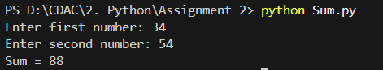
- Check Even or Odd:
num = int(input("Enter a number: "))
if num % 2 == 0:
print(f"{num} is Even")
else:
print(f"{num} is Odd")
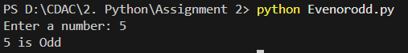
- Largest of three number
num1 = int(input("Enter first number: "))
num2 = int(input("Enter second number: "))
num3 = int(input("Enter third number: "))
if num1 >= num2 and num1 >= num3:
largest = num1
elif num2 >= num1 and num2 >= num3:
largest = num2
else:
largest = num3
print(f"Largest number is {largest}")
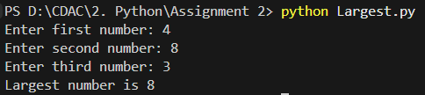
- Factorial of a Number
num = int(input("Enter number: "))
factorial = 1
for i in range(1, num + 1):
factorial *= i
print(f"Factorial = {factorial}")
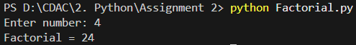
- Check prime number
num = int(input("Enter number: "))
if num > 1:
for i in range(2, num):
if num % i == 0:
print(f"{num} is not a Prime number")
break
else:
print(f"{num} is a Prime number")
else:
print(f"{num} is not a Prime number")
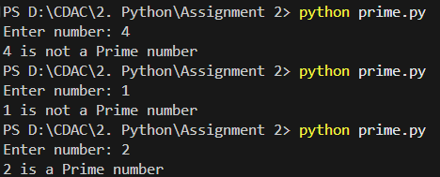

6. Fibonacci Series
num_terms = int(input("Enter number of terms: "))
a, b = 0, 1

for _ in range(num_terms):
print(a, end=" ")
a, b = b, a + b
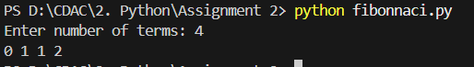
7. Reverse a Number
num = int(input("Enter number: "))
reversed_num = 0

while num > 0:
digit = num % 10
reversed_num = (reversed_num * 10) + digit
num = num // 10
print(f"Reversed number = {reversed_num}")
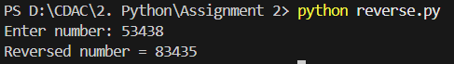

8. Check Palindrome Number:
num_str = input("Enter number: ")

if num_str == num_str[::-1]:
print(f"{num_str} is Palindrome")
else:
print(f"{num_str} is not Palindrome")
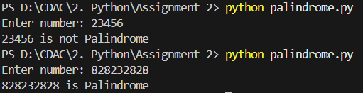
9. Sum of Digits
num = input("Enter number: ")
sum_digits = 0

for digit in num:
sum_digits += int(digit)

print(f"Sum of digits = {sum_digits}")
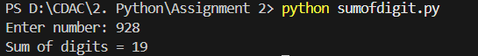
10. Count Vowels in a string:
str = input("Enter a word: ")
vowels = "aeiouAEIOU"
count = 0
for char in str:
if char in vowels:
count += 1
print(f"Number of vowels = {count}")

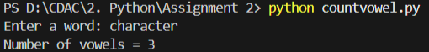
11. Reverse a string
str = input("Enter a string: ")
str = str[::-1]
print(f"Reversed string = {str}")
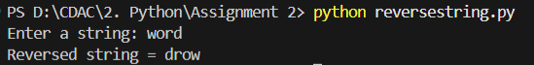
12. Check palindrome string
str = input("Enter a string: ")
if str == str[::-1]:
print(f"{str} is Palindrome")
else:
print(f"{str} is not Palindrome")
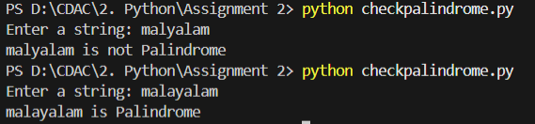
13. Find Maximum in list
# maximum in list

numbers = [10, 20, 5, 30, 15]
max_num = numbers[0]
for num in numbers:
if num > max_num:
max_num = num
print("Maximum number in the list is:", max_num)

14. Remove Duplicates from list
n = [1, 2, 3, 2, 4, 1, 5]
u = list(set(n))
print("Unique numbers in the list:", u)
15. Count Words in a sentence
s = input("Enter a sentence: ")
w = s.split()
word_count = len(w)
print("Number of words in the sentence:", word_count)
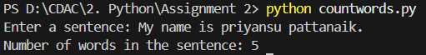
16. Multiplication Table:
n = int(input("Enter a number: "))
for i in range(1, 11):
print(n, "x", i, "=", n * i)
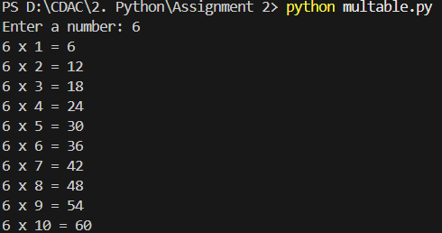

17. Swap two numbers:
a = int(input("Enter num1: "))
b = int(input("Enter num2: "))

a, b = b, a
print("After swapping: num1 =",a, "num2 = ",b)
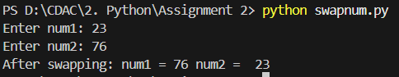
18. Armstrong Number:
num = input("Enter a number: ")
digits = len(num)
s = 0

for digit in num:
s += int(digit) ** digits

if s == int(num):
print(num,"is an Armstrong number")
else:
print(num, "is not an Armstrong number")
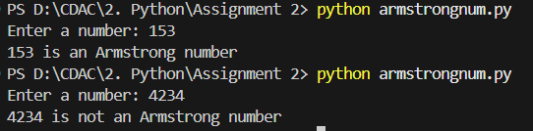

19. Second Largest Number in a list:
n = [1, 2, 3, 8, 9, 5]
n.sort()
second_largest = n[-2]
print("The second largest number in the list is:", second_largest)
20. Count Frequency of characters
text = input("Enter string: ")

freq = {}

for char in text:
if char in freq:
freq[char] += 1
else:
freq[char] = 1

for char, count in freq.items():
print(char, ":", count)

